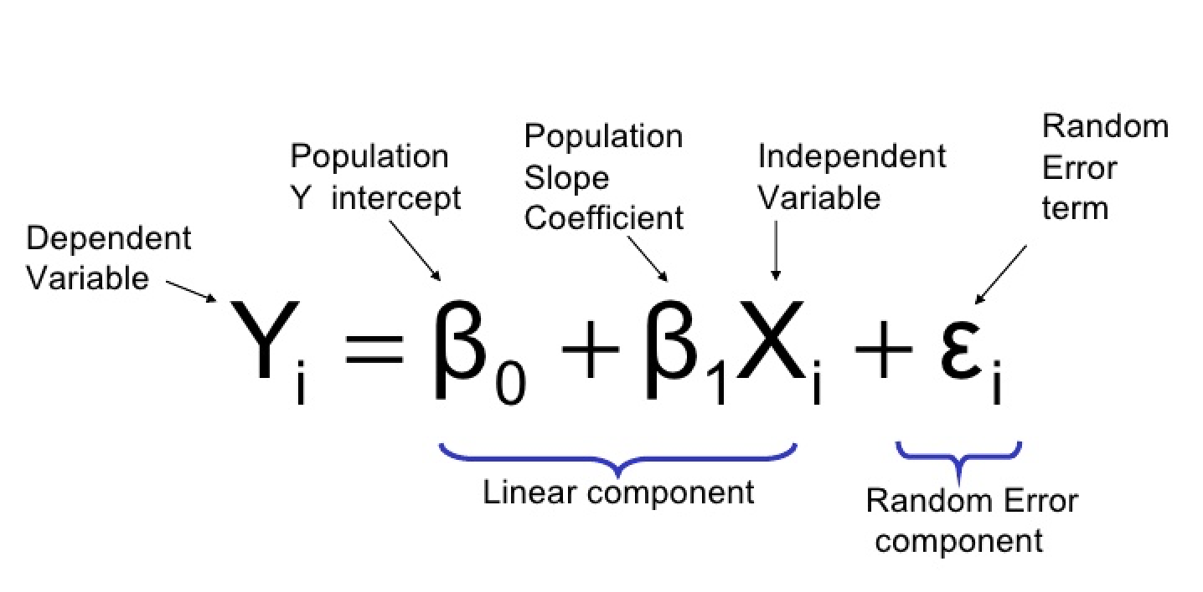

Above, we can see the simple linear regression equation. The y-variable is considered our response or dependent variable. This is what we intend to predict, for example, Sales is a popular choice.
The B0 is the y-intercept, i.e) Where X=0 and the line meets the y-axis. The B1X is essentially, our B1 (The amount of impact our X has on our y), and our X, which is our feature/independent variable. Unlike our y-variable, multiple X’s can be used with a corresponding beta (coefficient for each). This allows us to create a model with many feature (X) variables to predict values in y. The random error component is irreducible error.
First Step: Visualization
Using visualisation, you should be able to judge which variables have a linear relationship with y. Start by using Seaborn’s pairplot.
In this case, we have used “Sales” as our response/y. Substitute the variables list of beta’s with your anticipated feature list
Additional parameters to use:
size= : Allows you to manipulate the size of the rendered pairplot
kind= ‘reg’ : Will attempt to add line of best fit and a 95% confidence band. Will aim to minimize sum of squared error.
Second Step: SK Learn — Setting variables
Scikit-Learn expects X to be a feature matrix (Pandas Dataframe) and y to be a response vector (Pandas Series). Let’s begin by separating our variables as below.
Handling your features (X):
In this example, we are using the columns TV, Radio, and Social as predictor variables.
f you are wondering why a capital X is used for features, and lowercase y for response, it is mainly due to convention.
Third Step: SK Learn — Splitting our data
Splitting X & y into training and testing sets:
By passing our X and y variables into the train_test_split method, we are able to capture the splits in data by assigning 4 variables to the result.
Fourth step: SK Learn — Training our model
Firstly, importing of sklearn.linear_model is required for us to access LinearRegression. It then needs to be instantiated and model fit to our training data. This is seen below.
Fifth step: Interpreting Coefficients
The coefficients will allow us to model our equation with values for our beta’s. The linreg variable (assigned to a LinearRegression object), is able to have the intercept and coefficients extracted, using the code below.
The intercept will be your B0 value; and each coefficient will be the corresponding Beta for the X’s passed (in their respective order).
Sixth step: Making predictions based on your model
Making predictions based on your model is as simple as using the code below: passing the predict method your test data. This will return predicted values of y given the new test X data.
Seventh Step: Model Evaluation
There are three primary metrics used to evaluate linear models. These are: Mean absolute error (MAE), Mean squared error (MSE), or Root mean squared error (RMSE).
MAE: The easiest to understand. Represents average error
MSE: Similar to MAE but noise is exaggerated and larger errors are “punished”. It is harder to interpret than MAE as it’s not in base units, however, it is generally more popular.
RMSE: Most popular metric, similar to MSE, however, the result is square rooted to make it more interpretable as it’s in base units. It is recommended that RMSE be used as the primary metric to interpret your model.
Below, you can see how to calculate each metric. All of them require two lists as parameters, with one being your predicted values and the other being the true values
Eighth Step: Feature Selection
Once you have obtained your error metric/s, take note of which X’s have minimal impacts on y. Removing some of these features may result in an increased accuracy of your model.
So, We begin a process of trial and error, where the process is started over again, until a satisfactory model is produced. The steps below may be useful for this particular part.
- Replace feature_cols & X
- Train_test_split your data
- Fit the model to linreg again using linreg.fit
- Make predictions using (y_pred = linreg.predict(X_test))
- Compute RMSE
- Repeat until RMSE satisfactory

